CHAPTER 2 FINANCIAL MANAGEMENT

2.1 Need of Finance Sources of finance for enterprises -Short term, Medium term and long term sources.

Need of Finance

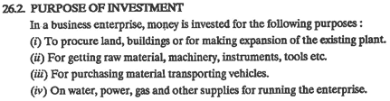

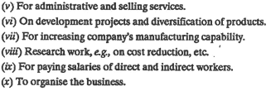

Sources of finance for enterprises -Short term, Medium term and long term sources.





External Sources of Income

a)Permanent or Long Term Sources

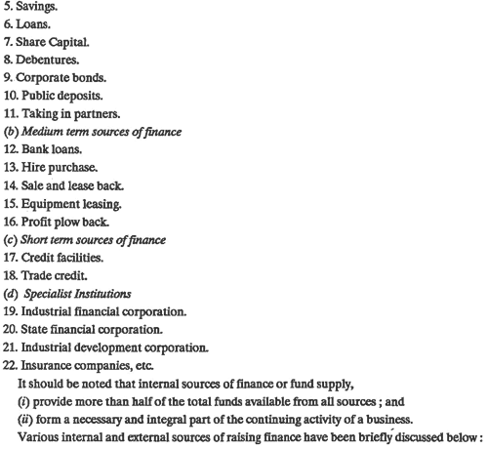

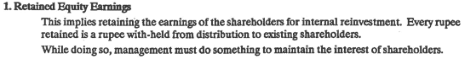

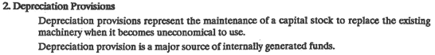

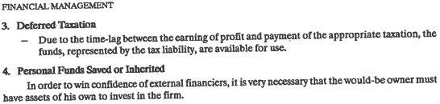

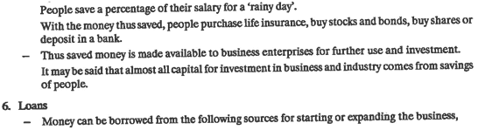

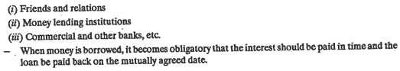

(2.2 Shares, debentures, types of shares and Comparison between shares & debentures)

7.Shares

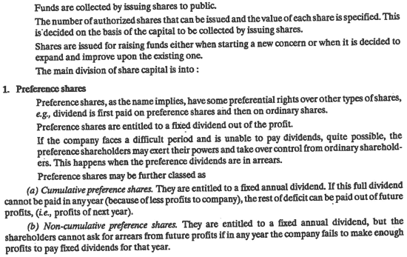

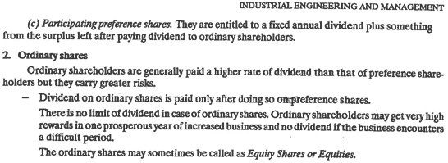

3.Deferred Share

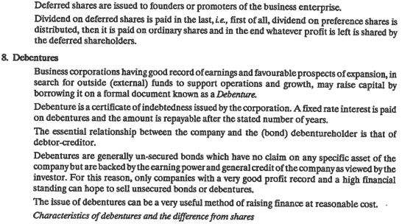

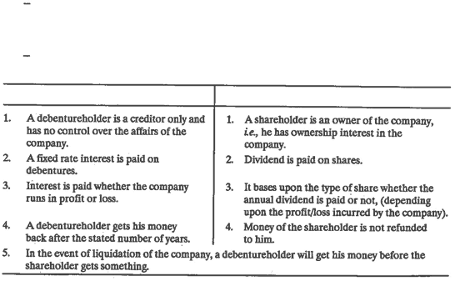

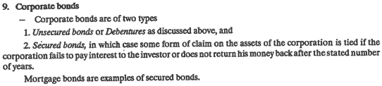

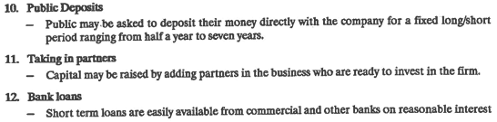

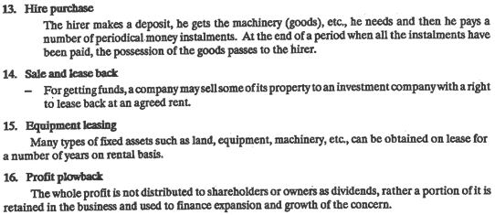









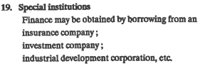

2.3 Break Even Analysis- Importance of Breakeven point, E.O.Q. (numerical on EOQ)

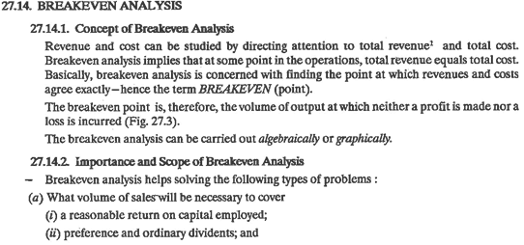

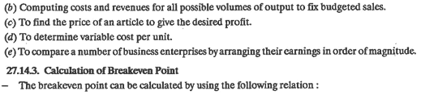



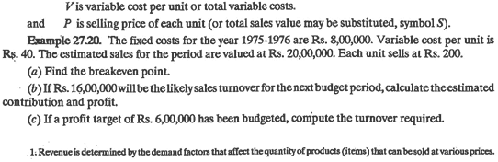

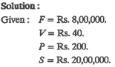



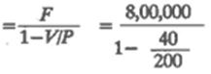

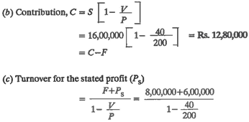





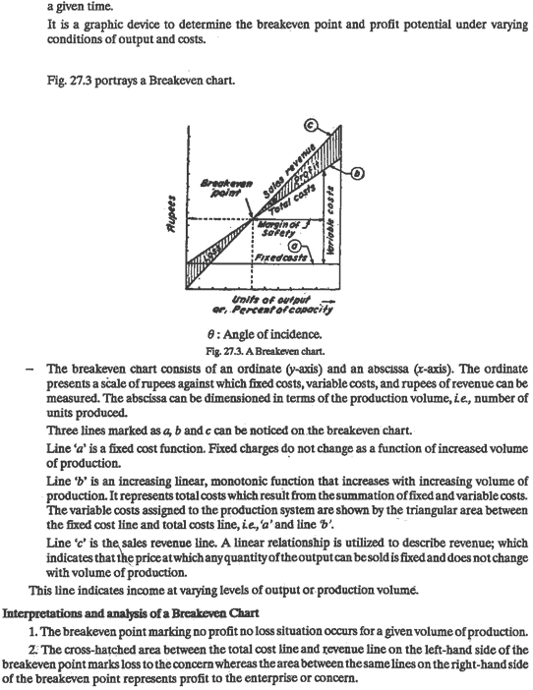

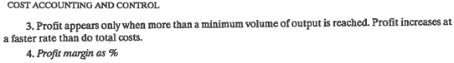

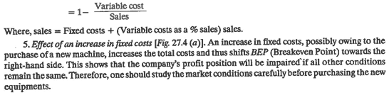

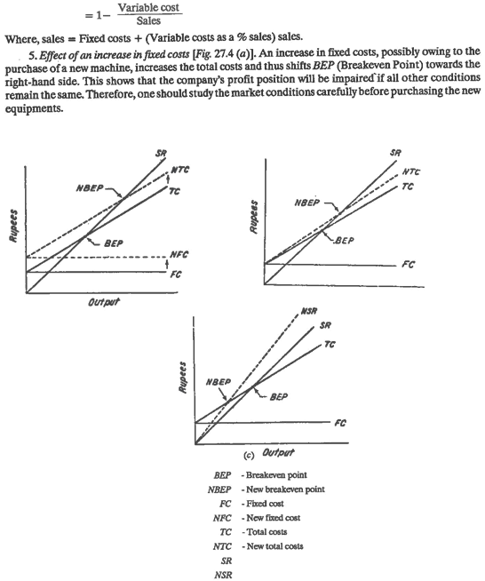



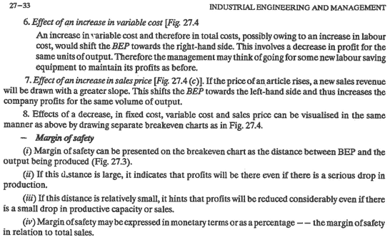



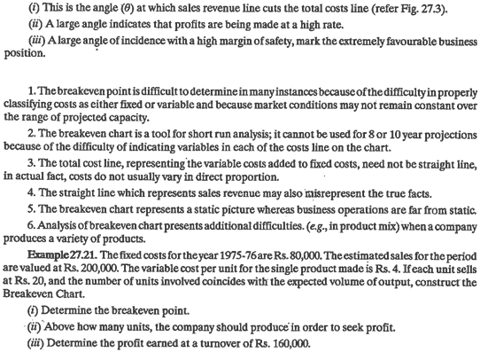

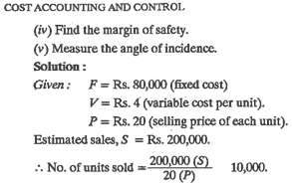

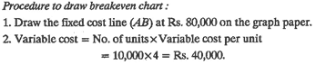

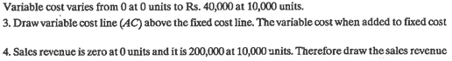

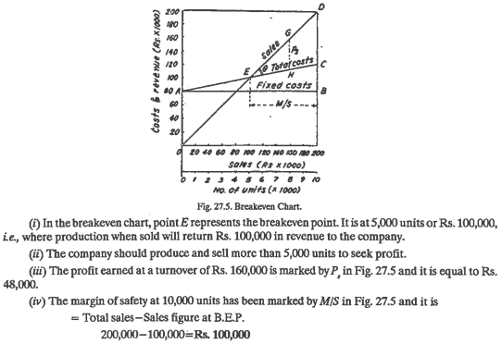



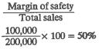

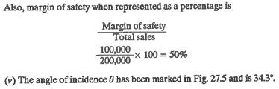

EOQ-

Economic order quantity (EOQ) is the ideal order quantity a company should purchase for its [inventory](https://www.investopedia.com/terms/i/inventory.asp) given a set cost of production, a certain demand rate, and other variables. This is done to minimize inventory holding costs and order-related costs.

Q=EOQ units

D=Demand in units (typically on an annual basis)

S=Order cost (per purchase order)

H=Holding costs (per unit, per year)

​

Q=√(2DS/H)

ABC Ltd. uses EOQ logic to determine the order quantity for its various components and is planning its orders. The Annual consumption is 80,000 units, Cost to place one order is Rs. 1,200, Cost per unit is Rs. 50 and carrying cost is 6% of Unit cost. Find EOQ, No. of order per year, Ordering Cost and Carrying Cost and Total Cost of Inventory.

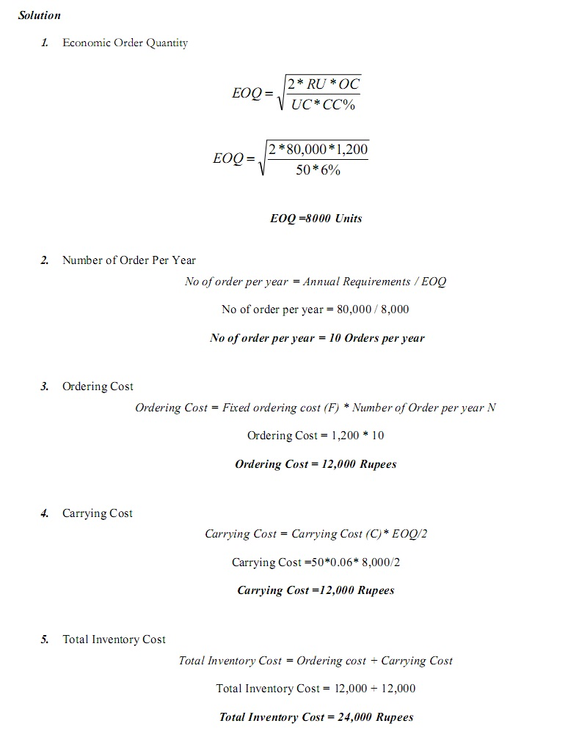

2.4 Types of capital: fixed and working capital



